Circuit Environment

Lab Report

NAME: | NEPTUN:
DATE: 19.11.2021 | LAB: 4

Task 1: Use the voltage waveform which observed at the sending end to find the values of the circuit:
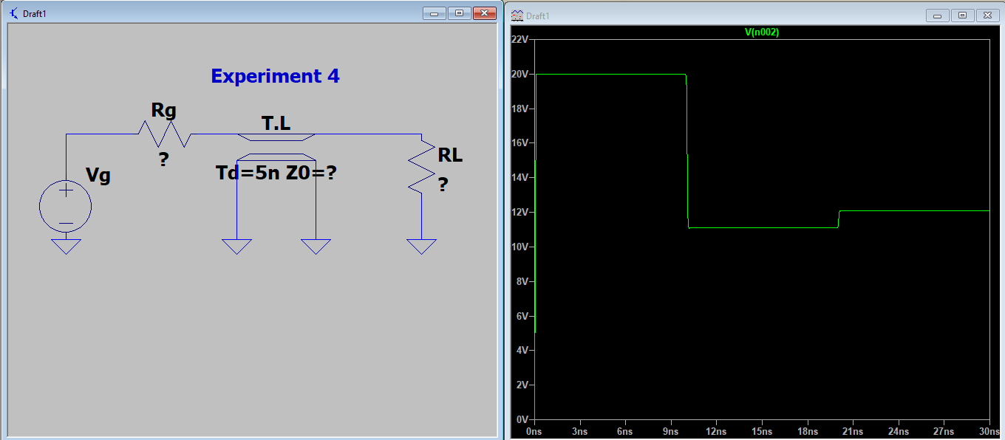

11.11V

20V

12.1V

Answer: Insert your screenshot here:

Task 2: Generate a bounce diagram and use it to plot V (t) at a point midway along the length of the line from t = 0 to t = 25 ns.
Answer: insert your solution here:

