Circuit Environment

Lab Report

NAME: | NEPTUN:
DATE: 19.11.2021 | LAB: 5

TASK: Use the following thermal Characteristic of BSC600N25NS3 Power-Transistor.
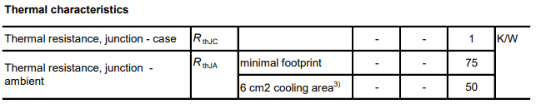

- Analysis the thermal junction of the transistor [between 100ºC and 150ºC].
- Convert the transistor package into 2R model and validate your model.
- Using heat sink system to reduce the temperature less than 50ºC.

Answer: insert your work here:

